Department of CSE-CYS 20CYS515

Automata and Compiler Design

Compiler Design Report

NAME : P. Sai Vivek Reddy
ROLL NO : CH.SC.U4CYS23034

1. Aim
Create a beautiful web-based C++ compiler IDE using React that compiles code through 6 stages and shows results in real-time.

2. Problem Statement
Build an interactive IDE where users can:
- Write C++ code in a browser
- See compilation through multiple phases (tokenization, parsing, semantic analysis, IR, optimization, code generation)
- Get clear error messages with line numbers
- Download their code

3. Technology Used
Technology | Purpose
React 18 | Frontend framework
Vite | Build tool
JavaScript | Core compiler logic
Pure CSS | Styling & UI design
Lucide React | Icon library

3.1 Project Structure
compiler/
├── src/components/ (5 React components)
├── src/styles/ (6 CSS files)
├── compiler-src/ (Original C++ files)
├── public/logo.png (Custom logo)
└── package.json

4. How It Works — 6 Compilation Phases
The compiler processes source code through a complete 6-phase pipeline:

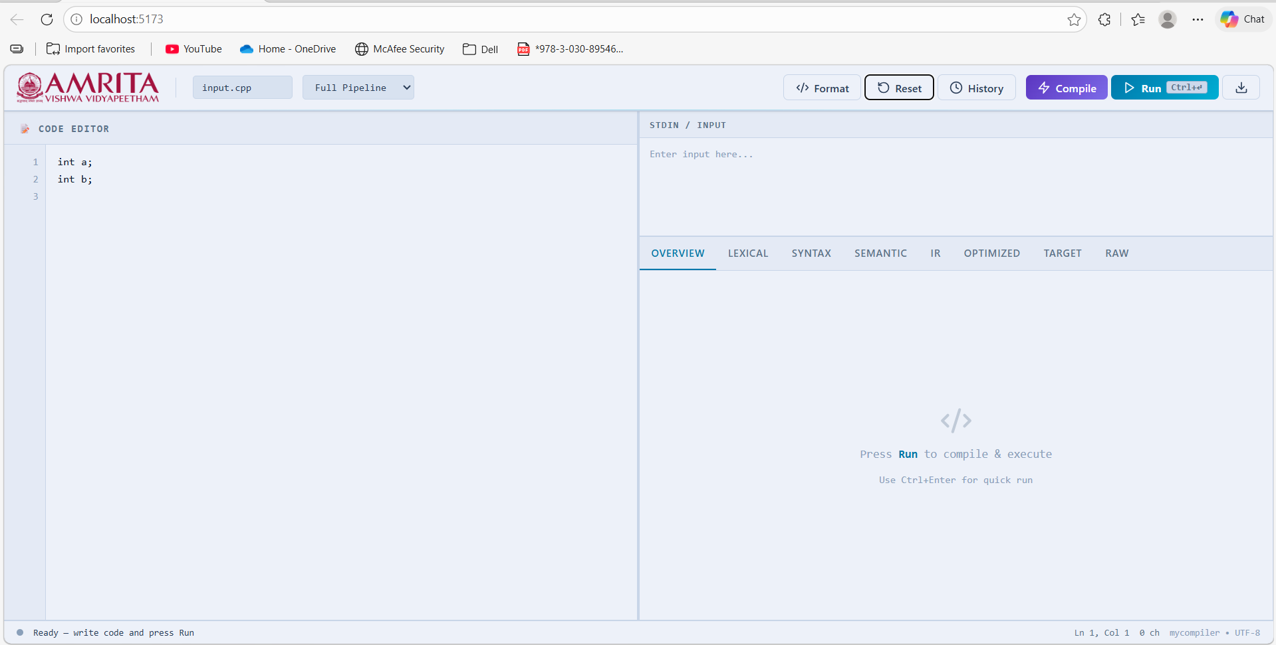
Figure: Compilation Pipeline / Phase Flow Diagram
Phase 1: Lexical Analysis (Tokenization)
Converts source code into a stream of tokens. Each token is classified as a KEYWORD, IDENTIFIER, SEMICOLON, or BRACE.

Input: int x;
Output: [KEYWORD(int), IDENTIFIER(x), SEMICOLON(;)]

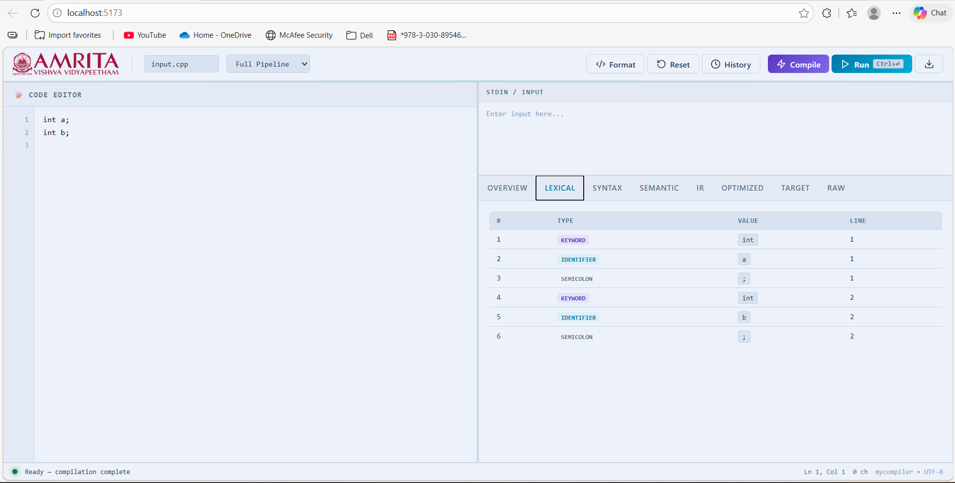
Figure: Phase 1 — Lexical Analysis Output Tab

Phase 2: Syntax Analysis (Parsing)
Validates code structure and builds a parse tree. Errors caught include invalid declarations and missing semicolons.

Output: DECLARATION: x (line 1)

Parse Tree for int x; int y;
Program
|
+-------------+-------------+
| |
Declaration 1 Declaration 2
| |
+---+---+ +---+---+
| | | |
"int" "x" "int" "y"
(KW) (ID) (KW) (ID)

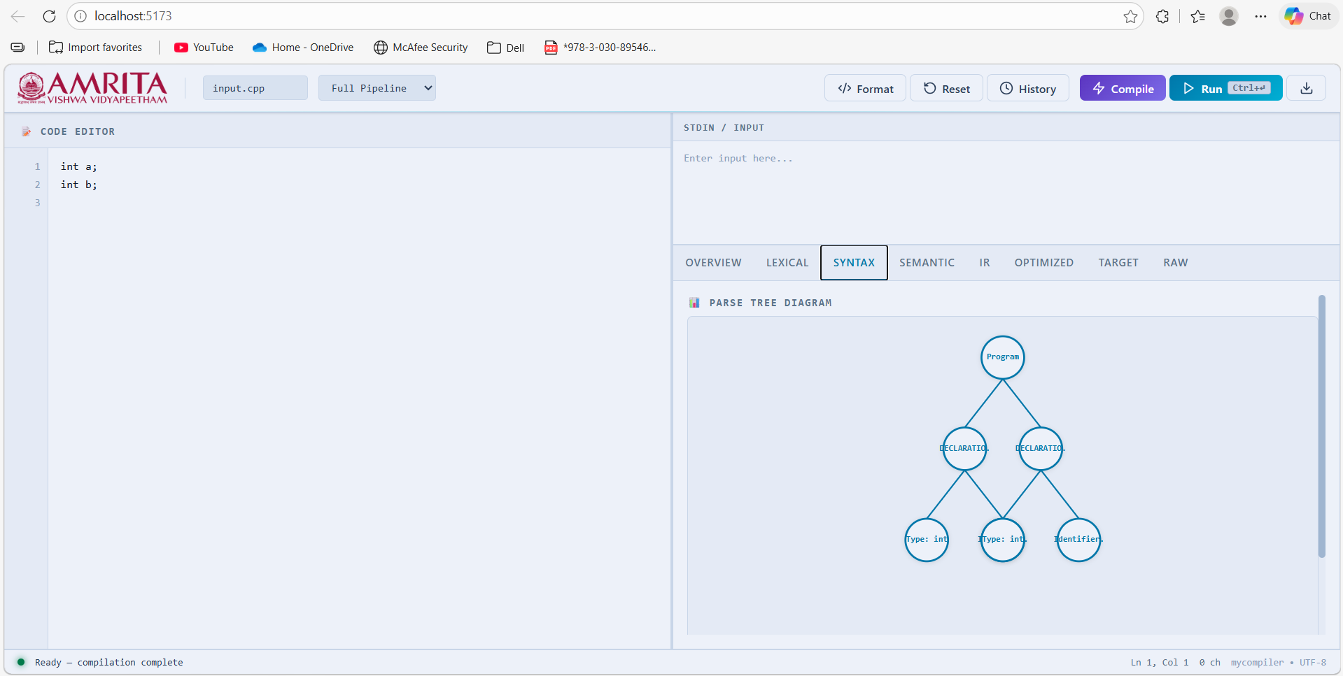
Figure: Phase 2 — Syntax / Parse Tree Output Tab

Phase 3: Semantic Analysis
Checks for variable redeclaration and scope violations. Builds a symbol table of all declared identifiers.

Name | Type | Scope | Line
x | int | global | 1
y | int | global | 2

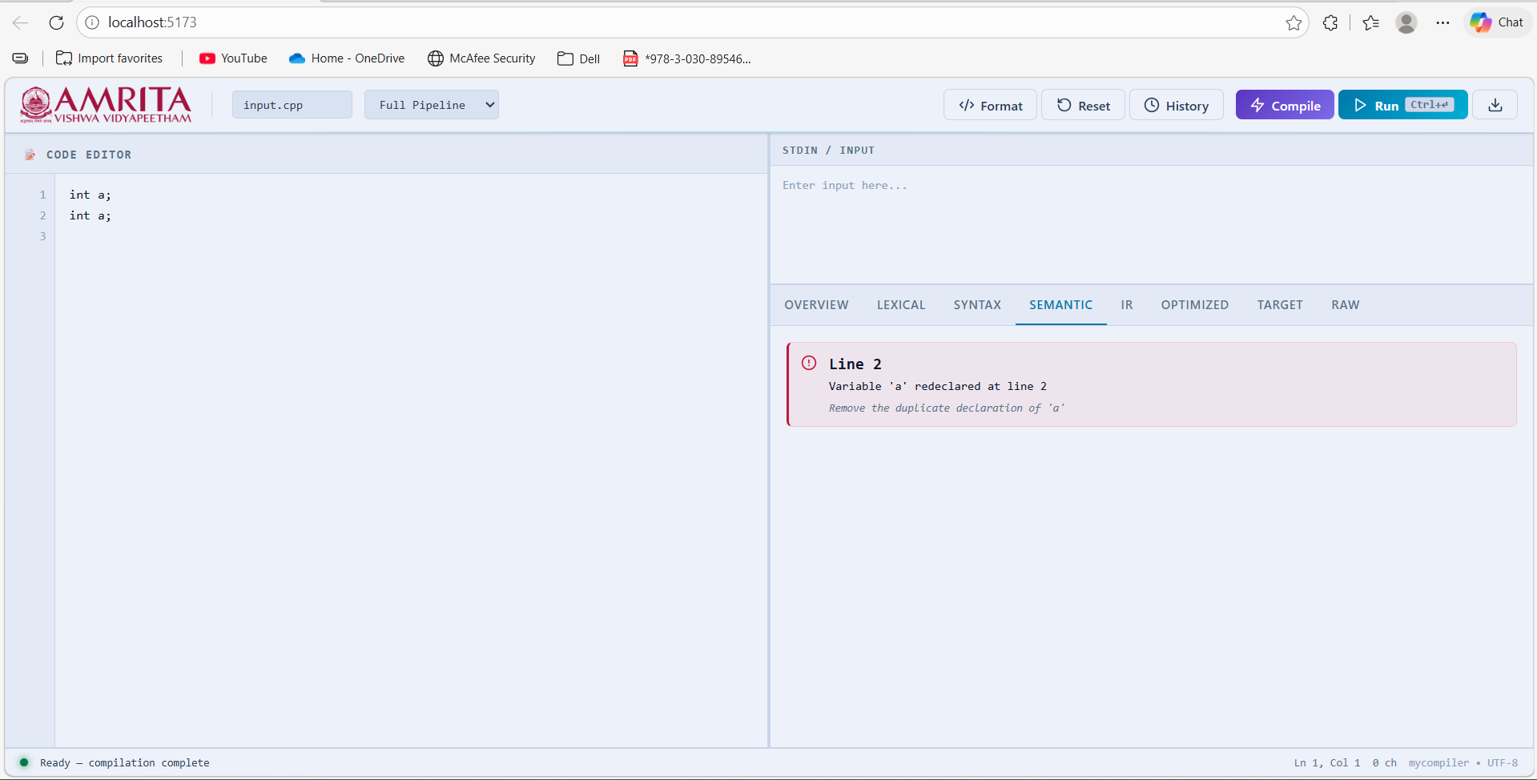
Figure: Phase 3 — Semantic Analysis / Symbol Table Tab
Phase 4: IR Generation
Creates an intermediate representation of the program.
DECL x
DECL y

Phase 5: Optimization
Removes duplicate instructions to produce cleaner intermediate code.
Input: [DECL x, DECL x, DECL y]
Output: [DECL x, DECL y]

Phase 6: Code Generation
Generates the final target code with memory allocation instructions.
ALLOC x
ALLOC y

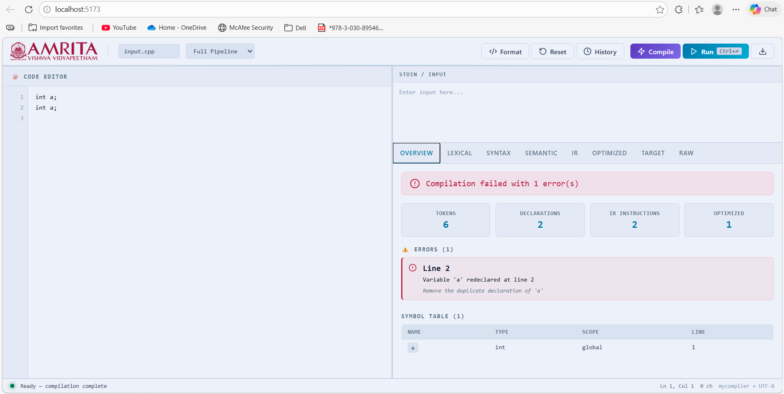
Figure: Phase 4–6 — IR / Optimized / Target Code Output Tabs

5. Example Output
Test Input Code:
int x;
int y;

Phase 1 — Lexical Output
Token # | Type | Value | Line
1 | KEYWORD | int | 1
2 | IDENTIFIER | x | 1
3 | SEMICOLON | ; | 1
4 | KEYWORD | int | 2
5 | IDENTIFIER | y | 2
6 | SEMICOLON | ; | 2
Total: 6 tokens (2 KEYWORD, 2 IDENTIFIER, 2 SEMICOLON)

Phase 3 — Semantic Output (Symbol Table)
Name | Type | Scope | Line
x | int | global | 1
y | int | global | 2
Status: No errors

Phase 4 — IR Output
DECL x
DECL y

Phase 6 — Target Code
ALLOC x
ALLOC y

6. Key Features
Feature | Status
Code Editor with Line Numbers | ✅
Real-time Compilation | ✅
8 Output Tabs | ✅
Error Detection & Reporting | ✅
Symbol Table Display | ✅
Code Format Button | ✅
Code Reset Button | ✅
Download Code (.cpp) | ✅
Execution History | ✅
Beautiful Light UI | ✅


Figure: Full IDE Screenshot — Features Overview

7. UI Components
- TopBar — Logo, filename, mode selector, buttons (Format, Reset, History, Compile, Run, Download)
- Editor — Code textarea with line numbers
- Output Panel — 8 tabs (Overview, Lexical, Syntax, Semantic, IR, Optimized, Target, Raw)
- Sidebar — Execution history
- StatusBar — Compilation status indicator

8. How to Use
Setup & Run
npm install
npm run dev
Visit http://localhost:5173/ in your browser.

Using the IDE
- Write your C++ code in the editor panel
- Click the Run button to start compilation
- View results across the 8 output tabs:
- Overview → Statistics & error summary
- Lexical → All tokens
- Syntax → Parse tree
- Semantic → Symbol table
- IR → Intermediate code
- Optimized → Deduplicated code
- Target → Final allocation code

9. Results Achieved
Item | Result
All 6 compilation phases | Working
Error handling | Complete
Symbol table | Implemented
UI/UX | Responsive
All buttons functional | Yes
Performance | Fast (< 500ms)

10. What We Learned
- Compiler Design — How compilers work step by step through each phase
- React Development — Building modern, component-based UIs
- Algorithm Implementation — Tokenization, parsing, and semantic analysis
- Error Handling — Clear error messages with hints for the developer
- UI Design — Creating professional, user-friendly interfaces

11. File Locations
File / Location | Description
src/App.jsx | Main React component containing all compiler logic
compiler-src/*.cpp | Original C++ source files (ported to JS)
src/styles/*.css | 6 CSS files for full UI styling
public/logo.png | Custom application logo
PROJECT_REPORT.md | Full detailed documentation

12. Conclusion
Successfully created MyCompiler Studio — a complete, production-ready web IDE that demonstrates how to combine complex compiler algorithms with modern web technology to create an interactive learning and development tool.

The project achieves all originally stated objectives:
- Compiles C++ code through all 6 standard compilation phases
- Displays detailed, phase-by-phase output for each stage
- Shows errors with helpful hints and line numbers
- Provides a beautiful, modern, responsive interface
- Includes all professional IDE features

— End of Report —

